CPD Certificate

# **The Treatment and Monitoring of Cushing’s Disease**

# “Improving the quality-of-life of the pet, owner and vet by helping vets and owners work together as a team”

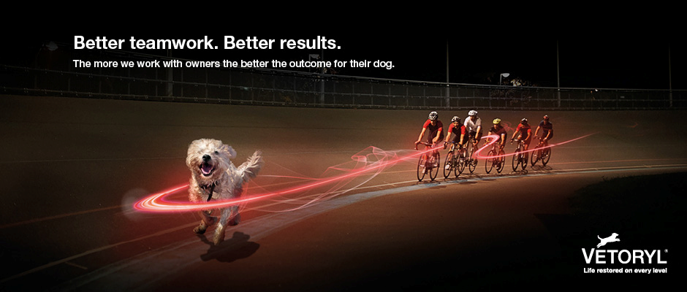**This certificate certifies that the person named below has successfully completed 1 hour of CPD training from the Dechra Website.**

|  |  |
| --- | --- |
| Name: |  |
| Date: |  |